Develop an Book api using python and flask

1. Create a folder in vscode and install flask microweb framework
2. Cmd:pip install flask
3. Run the below code in main.py

from flask import Flask, request, jsonify

app=Flask(__name__)

books_list = [

{

"id": 0,

"autor": "J Rowling",

"language": "English",

"title": "Harry Potter",

"Genre": "Fantasy",

},

{

"id": 1,

"autor": "Cao Xueqin",

"language": "Chinese",

"title": "Dream of the Red Chamber",

"Genre": "Family Saga"

},

{

"id": 2,

"autor": "Agatha Christie",

"language": "English",

"title": "And Then There Were none",

"Genre": "Mystery",

},

{

"id": 3,

"autor": "Paulo Coelho",

"language": "English",

"title": "The Alchemist",

"Genre": "Fantasy",

},

{

"id": 4,

"autor": "Umberto Eco",

"language": "Italian",

"title": "The Name of the Rose",

"Genre": "Mystery",

},

{

"id": 5,

"autor": "Beatrix Potter",

"language": "English",

"title": "The Tale of Peter Rabbit",

"Genre": "Children Literature",

},

{

"id": 6,

"autor": "Richard Adams",

"language": "English",

"title": "Watership Down",

"Genre": "Fantasy",

},

]

@app.route('/books',methods=['GET', 'POST'])

def books():

if request.method == 'GET':

if len(books_list) > 0:

return jsonify(books_list)

else:

'Nothing Found',404

if request.method == 'POST':

new_author = request.form['author']

new_lang = request.form['language']

new_title = request.form['title']

new_genre = request.form['genre']

iD = books_list[-1]['id']+1

new_obj = {

'id': iD,

'author': new_author,

'language': new_lang,

'title': new_title,

'genre': new_genre

}

books_list.append(new_obj)

return jsonify(books_list),201

if __name__ == '__main__':

app.run(debug=True)

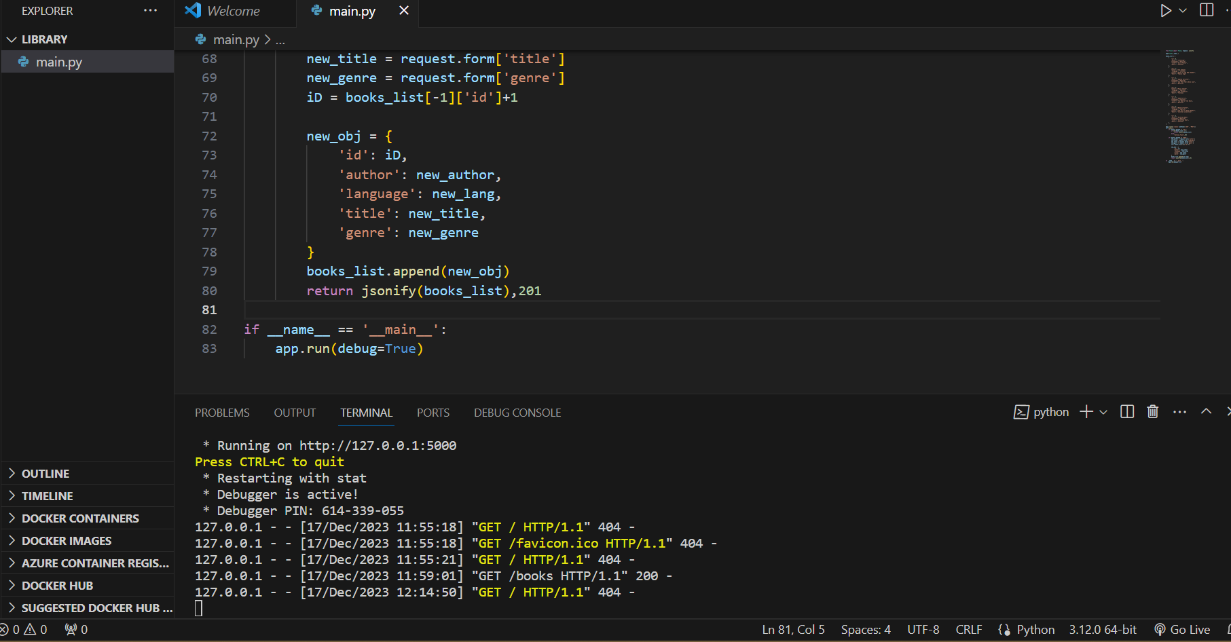

Open postman

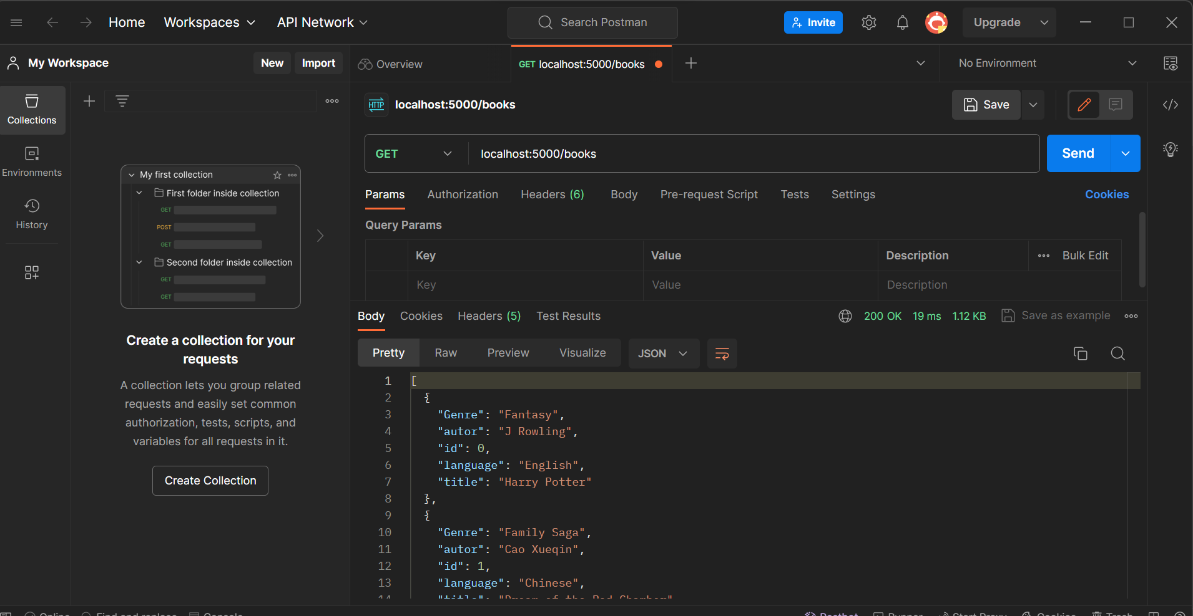

You will get the list of books available

You can add/create any book in the list using Post method

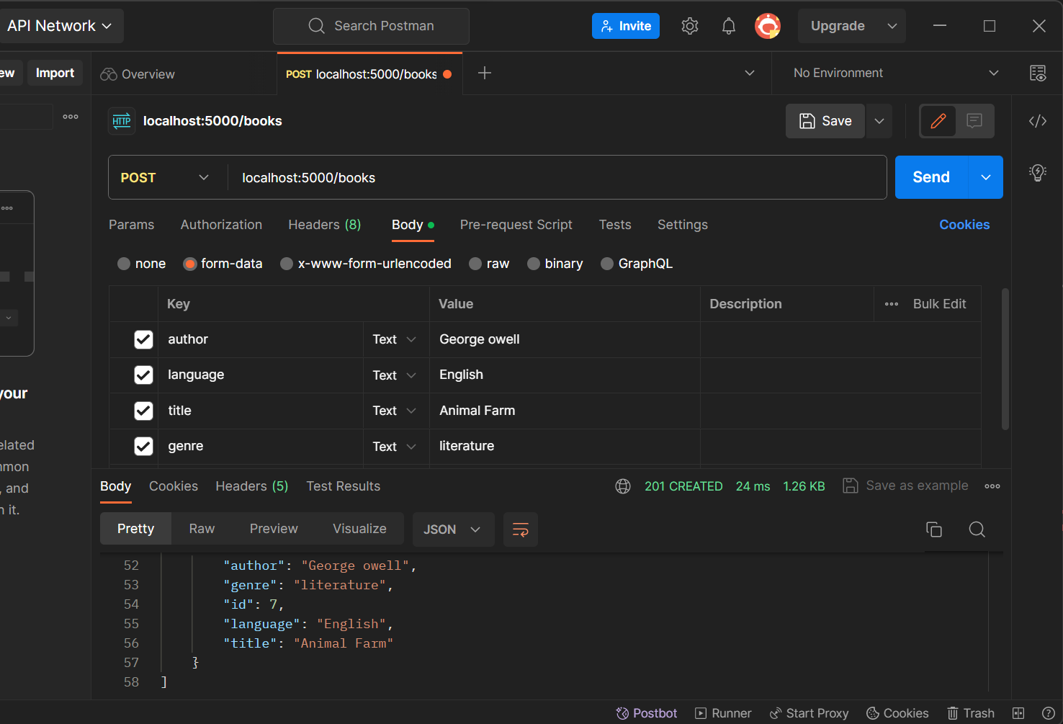

To perform operation on single object

@app.route('/book/<int:id>', methods=['GET', 'PUT', 'DELETE'])

def single_book(id):

    if request.method == 'GET':

        for book in books_list:

            if book['id'] == id:

                return jsonify(book)

            pass

    if request.method == 'PUT':

        for book in books_list:

            if book['id'] == id:

                book['author'] == request.form['author']

                book['language'] == request.form['language']

                book['title'] == request.form['title']

                book['genre'] == request.form['genre']

                updated_book = {

                    'id': id,

                    'author': book['author'],

                    'language': book['language'],

                    'title': book['title'],

                    'genre': book['genre']

                }

                return jsonify(updated_book)

    if request.method == 'DELETE':

        for index, book in enumerate(books_list):

            if book-['id'] == id:

                books_list.pop(index)

                return jsonify(books_list)

we can update ,delete any 1 record

